**Deliverable – 5**

**Understanding In-app Ads and Detecting Hidden Attacks through the mobile App -Web Interface.**

Table of Contents

I. Project Details 6

II. Requirement Specification for Phase - 2 7

1.1 Admin Module Requirements: 6

1.2 User Module Requirement: 8

2. Non-Functional Requirements Developed Under Phase - 2 12

2.1 Security Requirements: 12

2.2 Privacy Requirements: 12

2.3 Scalability and performance Requirements: 12

2.4 Usability Requirement: 12

2.5 Compatibility Requirement: 12

3. Interfaces (user, hardware, software, and/or communication) Developed Under Phase - 1 12

3.1 Hardware Interface Requirements: 13

3.2 Software Interfaces Requirements: 13

3.2 User Interface: 13

III. UML Design 16

1. Class diagram 16

2. Sequence diagram 17

3. Use case diagram 18

IV. Test Cases 20

V. User Manual for Phase - 1 31

VI. Program Compilation and Run Instructions 55

1. Program Instructions 55

2. Testing Instructions 56

VII. Feedback 56

VIII. Accomplishments 57

IX. Member contribution table 57

# PROJECT DETAILS

**Project Title: Project Title:**  **Understanding In-app Ads and Detecting Hidden**

**Attacks through the mobile App -Web Interface.**

**Group Name:** Team Resolve

**Group Members:**

1. Navyasri Arekatla
2. Lokesh Bachu
3. Sushma Bobbishetty
4. Naveen Bolgom
5. Sathvik Cheekati
6. Vamshi Teja Goud Puli
7. Shiva Teja Reddy Yammanuru

# Requirement Specification for Phase - 2

## Functional Requirements Developed under Phase – 2 with respect to each module

Phase-2 has seen the addition of a few new functionality and the modification of a few already existed features.

### Admin Module Requirements:

#### Registration :

• In addition to this project, the server must also be started. This gives us access to the project dashboard and all associated files.

• During the registration process, administrators must enter the data required to register with the browser.

• Our system does not use a browser; Apache is used instead. Web pages are served to users through software known as Apache, which acts as a web server listening and responding to HTTP requests sent by users. • The "Admin Login" button is located on the home page and clicking on it will start the administrator registration process. You will then be prompted to enter your company email and password.

• Users who click the button are directed to a page that requires them to register.  
• Following the administrator's enrollment in this course. Now is the good time to use the browser.

#### Login-Validation:

• To login, this administrator must click on the icon labeling Admin Logins. The person credibility was thoroughly interogated.

•this error message "Invalid user name or password" is displayed if any of the information is incorrect.

• Whenever you like, you can change your password by visiting your settings and selecting "Forgot Password."The fields for email ID, phone number, new password, and password confirmation are all currently blank.If the appropriate email address and phone number are provided, the password updates can be completed successfully. If you select "Cancel," the update will no longer be downloaded.

#### Dashboard-Display:

The following sections are in admin dashboard:

##### ADMIN MENU:

The admin has access to a variety of settings through a menu called "Admin" which offers a variety of options.  
The admin accesses are the following:

**View all users and authorize**: We are able to review all of the user requests and make a determination regarding whether or not to grant them based on the particulars of each case. Only the administrator can create authorized users, and those people alone can access the user dashboard. The administrator is the only one who can generate authorized users. The administrator is the only person who can create authorized users.

**View all android users**: This module contains information about all Android users.  
**View advertisement request users:** This section displays advertisements requested by the user. We are able to honor the request using this interface.  
 **View friend request and responses:** This section of the module displays all friend requests and responses to those requests.  
**View All user’s advertisement with rank and rating** In this section, all ads registered by users are compiled and displayed with their position and score. This module gives users the ability to access information associated with the malicious user.

**View all Malicious user details:** This gives the admin the ability to identify malicious people and block those people from accessing additional advertisements.  
**View all advertisement recommended users details:** This module displays advertisements recommended by other users.  
**View malicious publishers:** This component provides the administrator with a list of all malicious publishers reported by users. This module helps administrators determine how to avoid fake publishers for advertising purposes.

**View all android hidden attackers:** This module grants the admin the ability to see all hidden Android attackers and it is useful for this purpose.  
**View all expired advertisements:** This module gives the admin the option to view all the expired listings since.  
**View all blocked users :**This module allows you to view all users who have been blocked by the administrator.  
**View all blocked user’s evidence:** This module provides the administrator with a complete overview of all evidence associated with blocked users.  
**View user type count in chart** Admin can use this module to display all the type counts given in the chart to the user. This gives the admin the ability to view all ad rankings in the order they were received.

**View all advertisement ranks in chart:** The admin can check this and see where each of his ads are currently in the ranking.  
**Logout**: Selecting this option allows the admin to completely log out of the dashboard.

### 1.2 USER REGISTER MODULE Requirement:

#### Registration:

• If you want to use our web browser, you need to sign up for an account and give us the information we need. This includes their job email address and the password they need to get into their account. Our web browser would not work if Apache wasn't running in the background.

• Users can start the signup process by clicking "User Registration Login" from the website's page. Then he has to put in his email address and choose a password. When they click the button, a page to register opens and asks them to fill in the necessary information.

• After completing the registration process, users can log in to their accounts through a computer browser. Because of this, they can use all of our browser's features and functions.

**LOGIN VALIDATION:**

• Users can go to the site to sign up for an account. Before people can use this service, they have to sign up on the website and give important information. After signing up, users can go to the user part and log in.

• Users have to choose "USER" from the dashboard menu and then enter their passwords to get to the user part. Before a person can use the user module, they have to sign up as a user and have their registration accepted by the administrator.

The user dashboard doesn't show up until the manager says yes to the user's request. If a user wants to keep an ad on the website to promote his ads, he will send a request to the admin.

**PERSON’S MENU:** The person Dashboard gives the person a full view of all of the features that are available to them.

The person's information is on the page. In this part, information about the user is shown.

Search for friends: This tool lets us look for friends and meet new ones. We can find and invite friends.

Manage bank accounts: One part of the system tells the person what account they are using. On this form, users can put details about their bank account and register it. This form also lets people check their account balance.

Send a request to the administrator to start a new ad:

• This is where we write in the date and time we want the message to show up. The boss will then go over the request and say "yes."

• If we accept your entry, we will have to pay to put your ad in the paper.

**ADD ADVERTISEMENT DETAILS:**

Once the boss has given us permission to put up an ad, we can add the ad's information in the right window.

• Asks for information like the type of browser, the name, file, content, and length of the ad.

With this function, you can see what ads have been loaded and for how long each one will run. You can also get rid of the ads that you no longer want to see. • With this feature, you can look at all of the ads that have been put and see how long each one will be up. You can also choose to get rid of any ads that you no longer want to see.

**ALL MY FRIENDS ADVERTISEMENT DETAILS AND RECOMMEND TO OTHER FRIENDS:**

• In this lesson, we can see what our friends say and tell other people about them.

**FRIENDS RECOMMENDED ADVERTISEMENTS:**

• This part lets you see what ads have been put up and for how long each one will be shown. You can also get rid of the ads you don't want to see anymore.

**LOGOUT:** Users can just click on this button to log out.• Users must create an account with us and provide us with relevant information in order to use our web browser. This information consists of their professional email address and the password required to access the relevant account. Without the Apache program running in the background, our web browser would not work.  
• Users can start the registration process by selecting “User Registration Login” from the website menu. He must then enter his e-mail address and choose a password. After clicking the button, the registration page opens and asks them to enter the necessary information.  
• User can access their accounts through a web browser and log in after completing the registration process. As a result, they can use all the features and functions of our web browser.

## Non-Functional Requirements Developed Under Phase - 1

### Security Requirements:

Phase 1 of the development process involved creating non-functional requirements for the application. The first requirement concerns the security provided by the Java and JavaScript functions of the HTML file. The app can only be used on authorized websites to prevent unauthorized access.

### Privacy Requirements:

In accordance with data protection requirements, the application only collects the user's email address during registration and does not disclose personal data. JavaScript is used to authenticate the user and ensure that only authorized users can access the application. The scalability and efficiency require the use of a cloud server and domain to host the application, and the project is comparable in complexity to larger projects.

### Scalability and performance Requirements:

This app provides users with a web-based platform that allows them to not only create and manage their own ads, but also connect with each other. To use this platform, we need a cloud server and a domain to host the application on. This project is comparable in complexity and scope to larger projects.

### Usability Requirement:

1. Usability is an important requirement and the application is designed to be user-friendly using technologies such as Ajax, Query and Java. Ajax enables asynchronous communication between the front-end and the back-end, which improves the user experience by reducing wait times and increasing responsiveness. A query simplifies code, making it more readable and maintainable. Java is used for scalability and performance.

### Compatibility Requirement:

Running our application on following browsers is more compatible:

1. Chrome Browser Version 98.0.0.0 or above
2. Microsoft Edge Version 90 or above
3. Safari Browser Version 13.1.2 or above

## Interfaces (user, hardware, software, and/or communication) Developed Under Phase - 2

### Hardware Interface Requirements:

This application can be runed on a web browser which is installed on **Laptop / PC**.

### Software Interfaces Requirements:

1. **HTML**: For website Designing.
2. **JQUERY:** For styling the website Design.
3. **AJAX:** Used for Dynamically loading the webpages.
4. **JavaScript**: This Technology is used to apply validations for web pages and redirections etc.,
5. **SQL:** We will be using SQL for accessing the database.
6. **Visual Studio:** We will be using Visual Studio as Integrated Development Environment for the Project.
7. **Apache Tomcat:** It is used as a server for deploying the application.

### User Interface:

This is the landing page for the application, which can be accessed using this link.

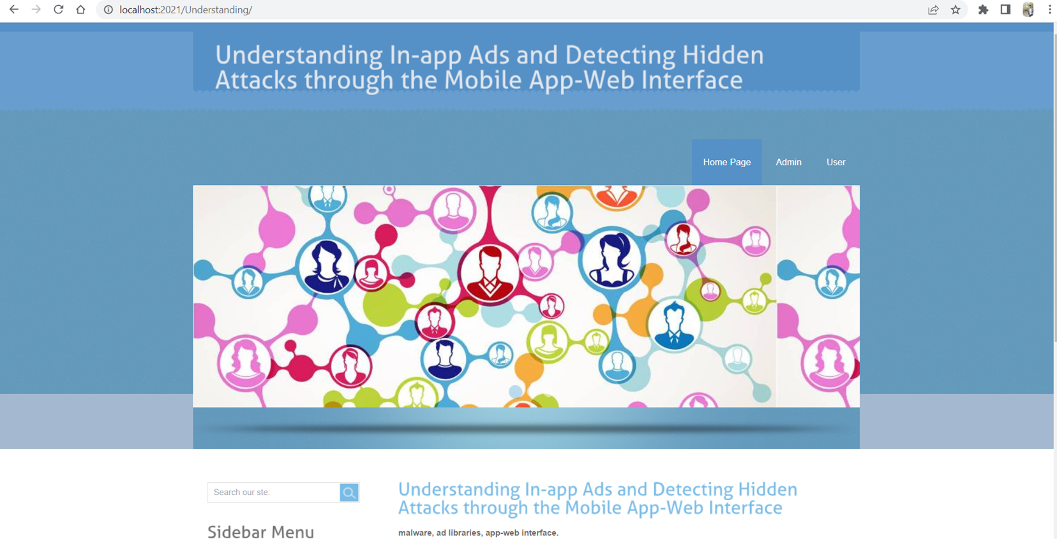

Step 2: User On this page, you can select several options from the menu, such as "Home," "Admin," and "User."

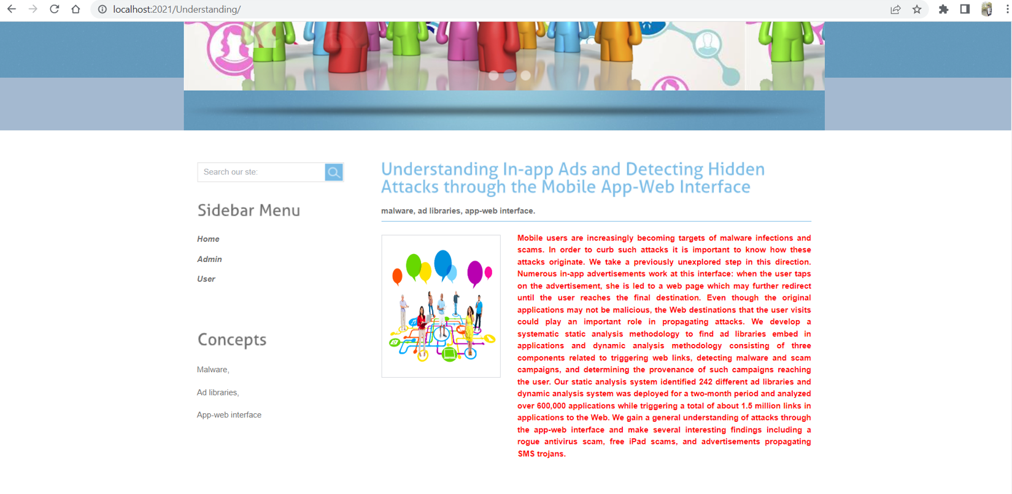

Step 3: This page can be accessed by choosing the user from the menu that appears at the top of the screen. This is the page that allows users to log in. In our capacity as a new user, we are required to select the Register here option.

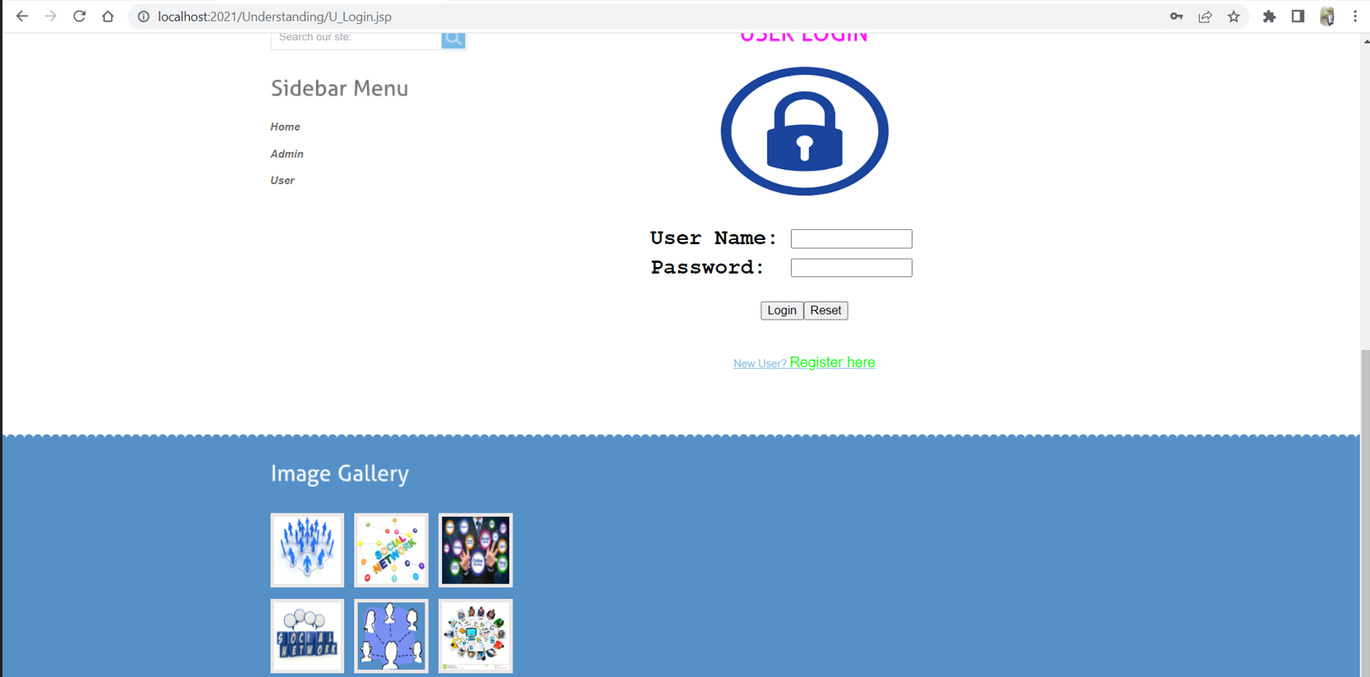

Step 4: If you choose to register here, we require you to furnish us with certain information about yourself.

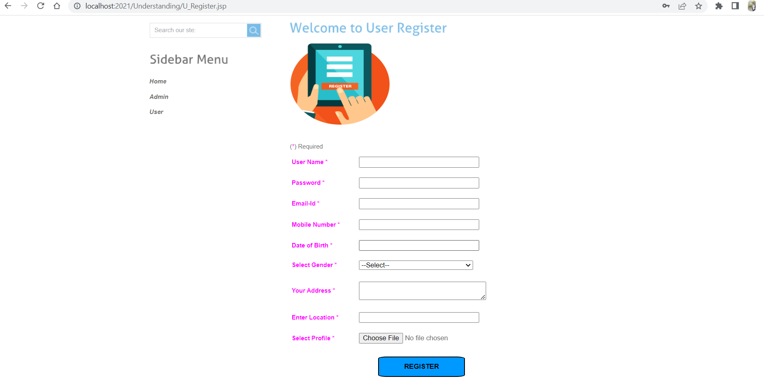

Step 5: In the below screenshot, for the registration, The user details are displayed here

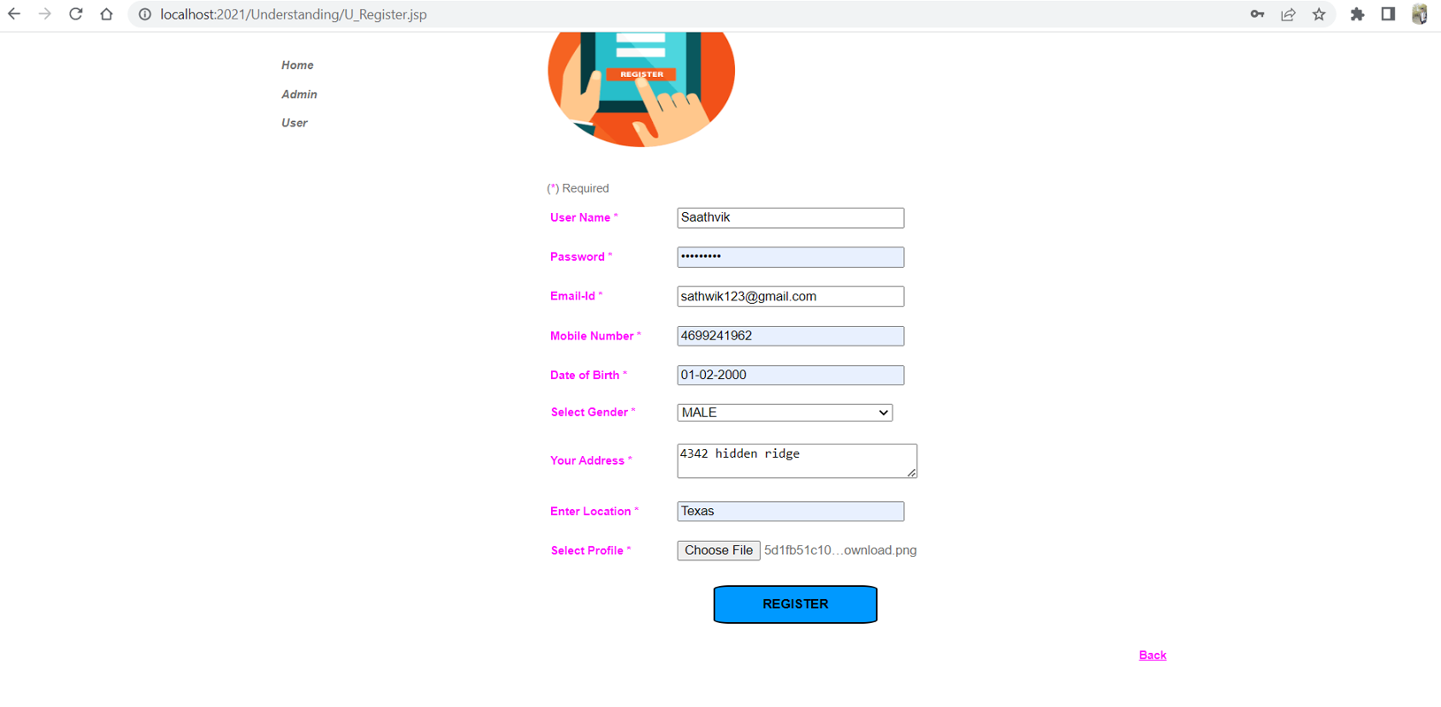

Step 6: This page will appear after the registration procedure has been successfully completed, provided that it was completed successfully.

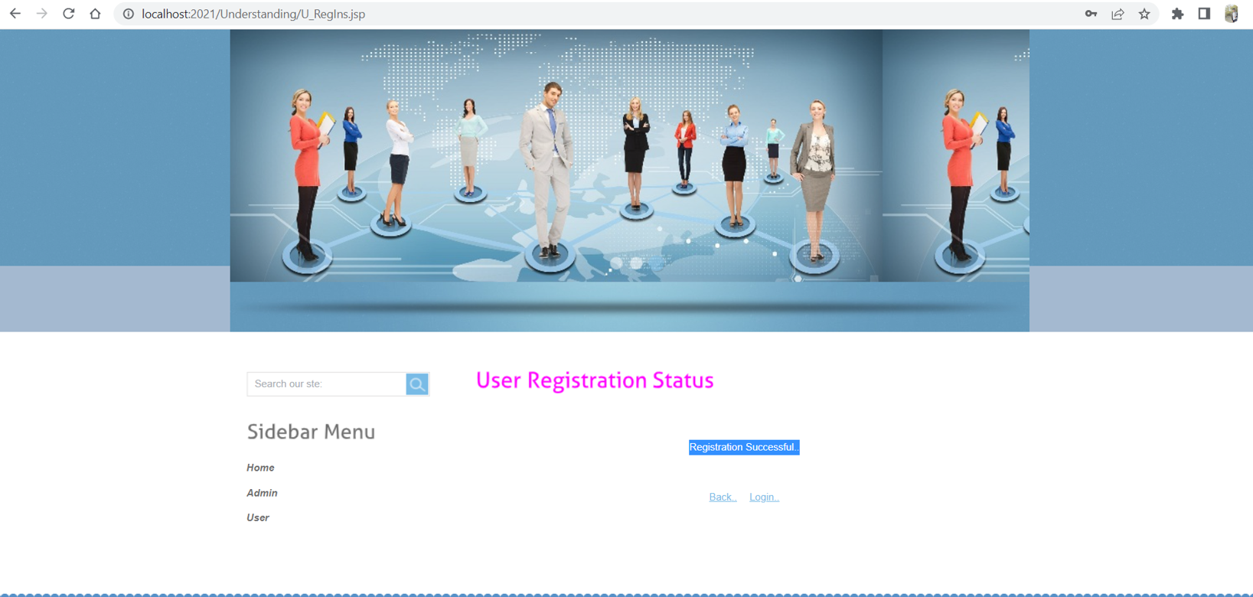

Step 7: Here is the User Login Page

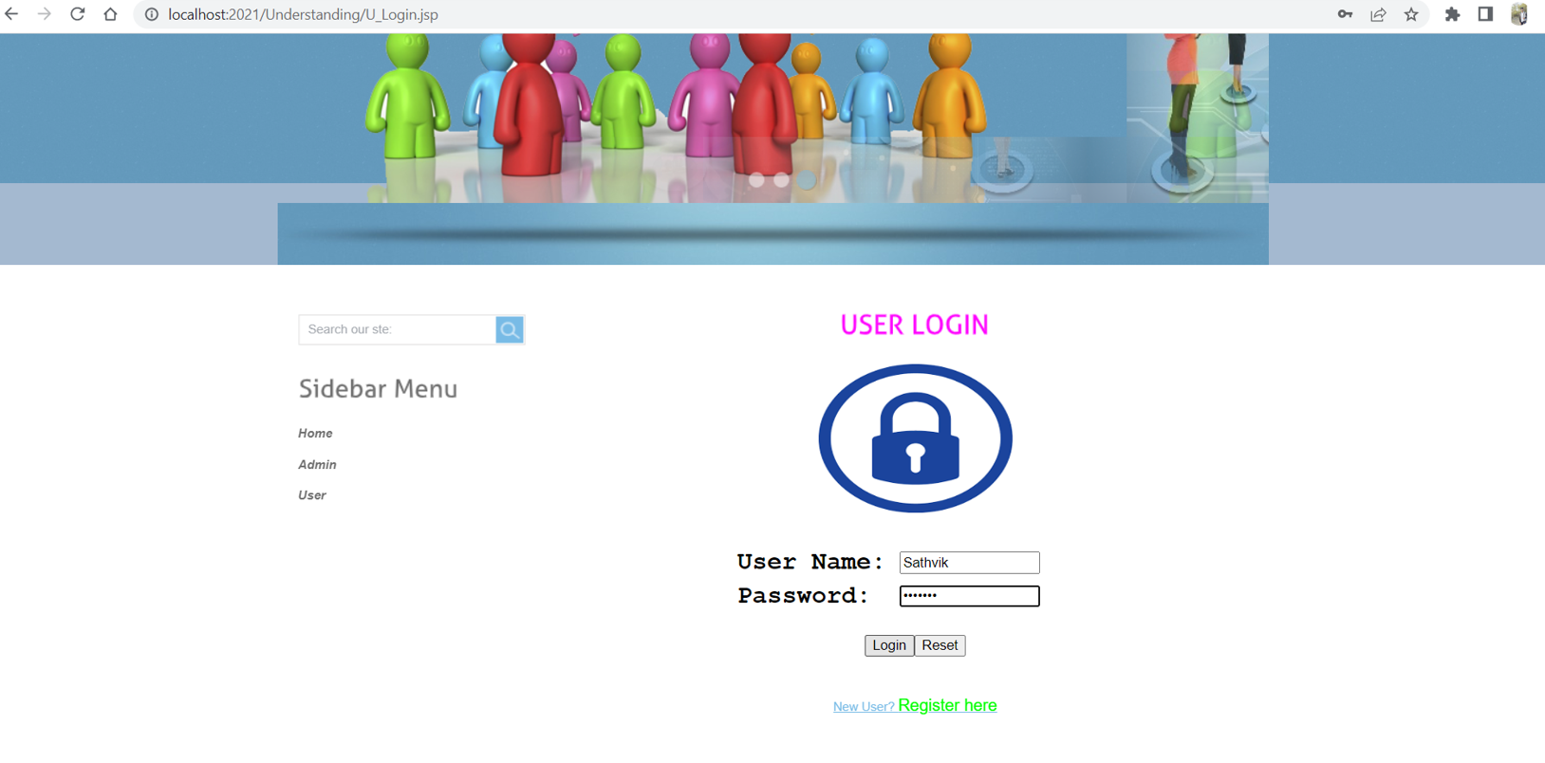

Step 8: Below screenshot is the admin page for the application.

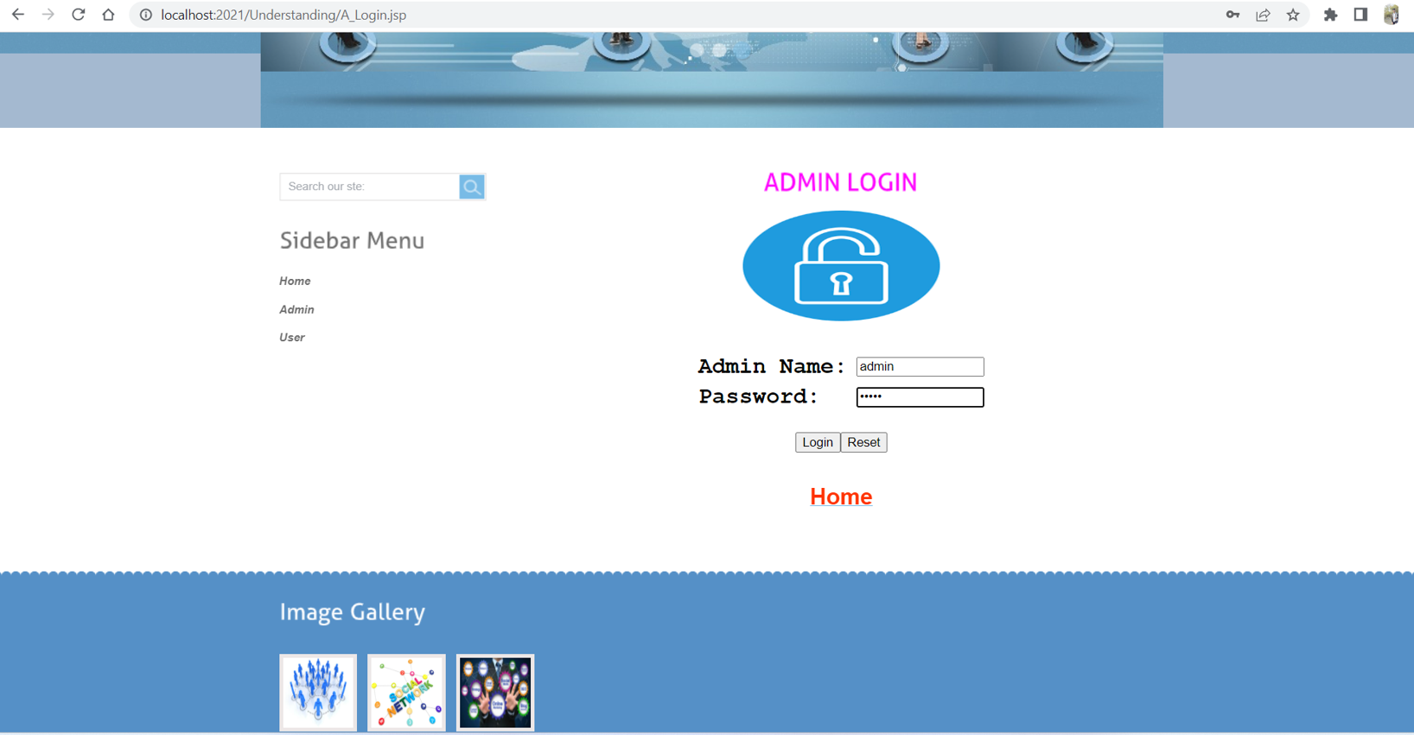

Step 9: In the below screenshots it displays the home page of the admin page.

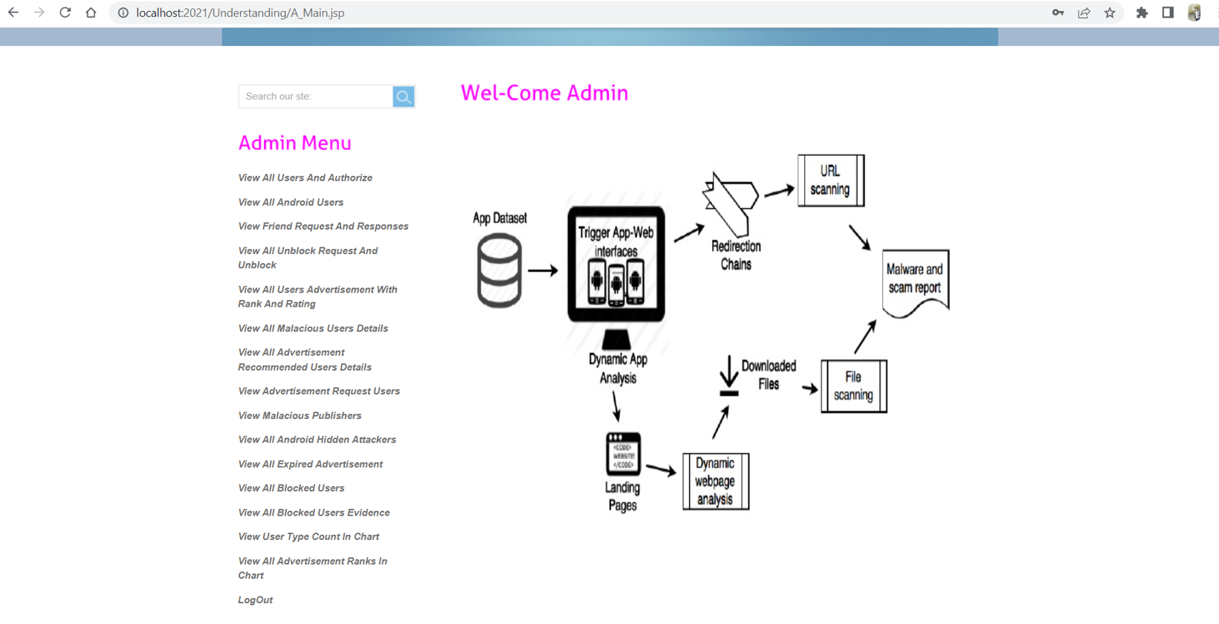

Step 8: By choosing the View All Users And Authorize choice, you can see the next page. Before a person can log in to this program, the administrator needs to give them permission to do so.

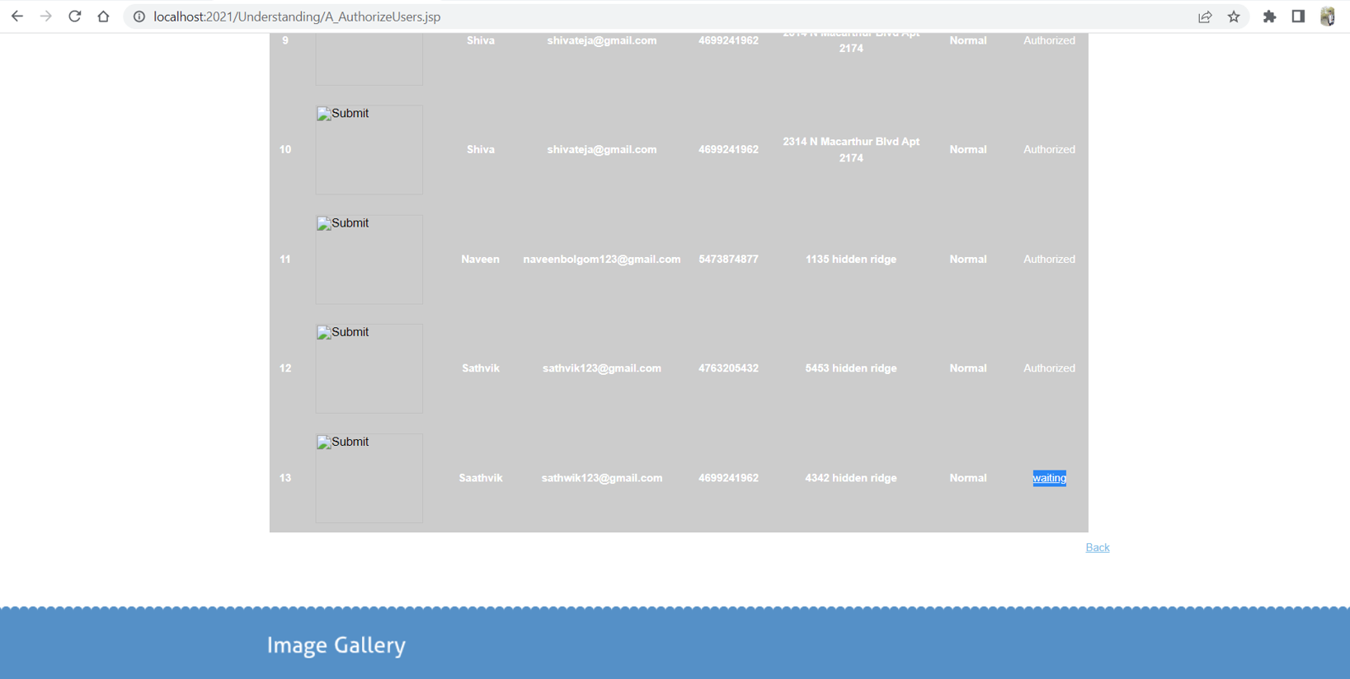

Step 9: After the successful authorization, user can login into their account.

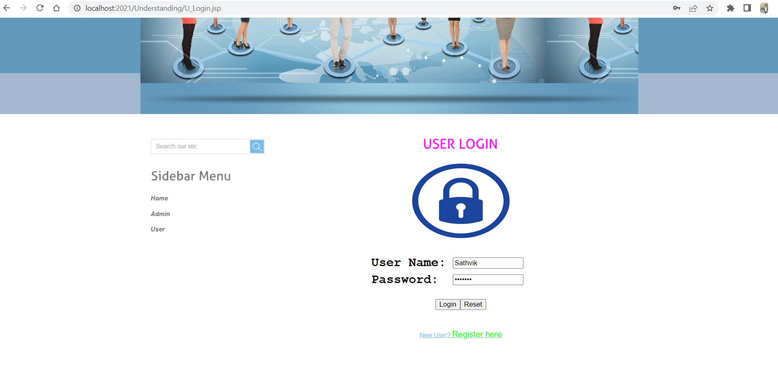

Step 10: The user home page for the application is shown in the below screenshot.

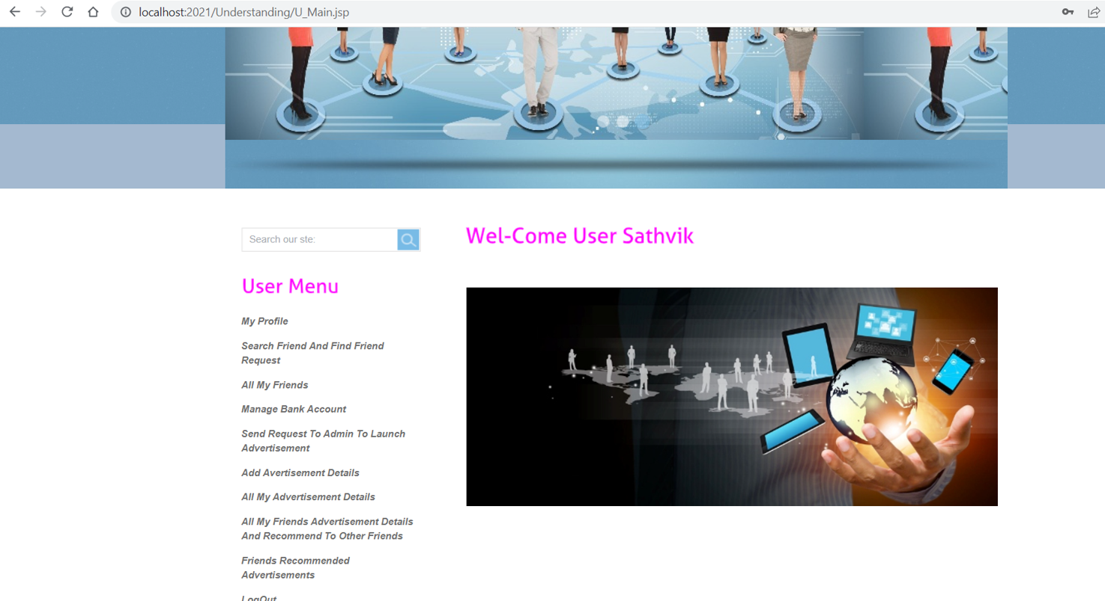

# UML Design

## Class diagram

## 

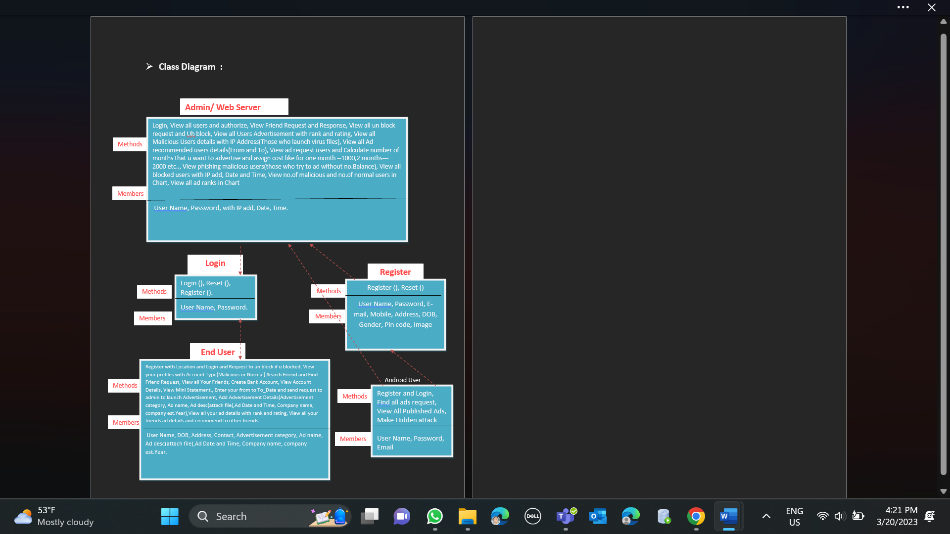

Figure : Class Diagram

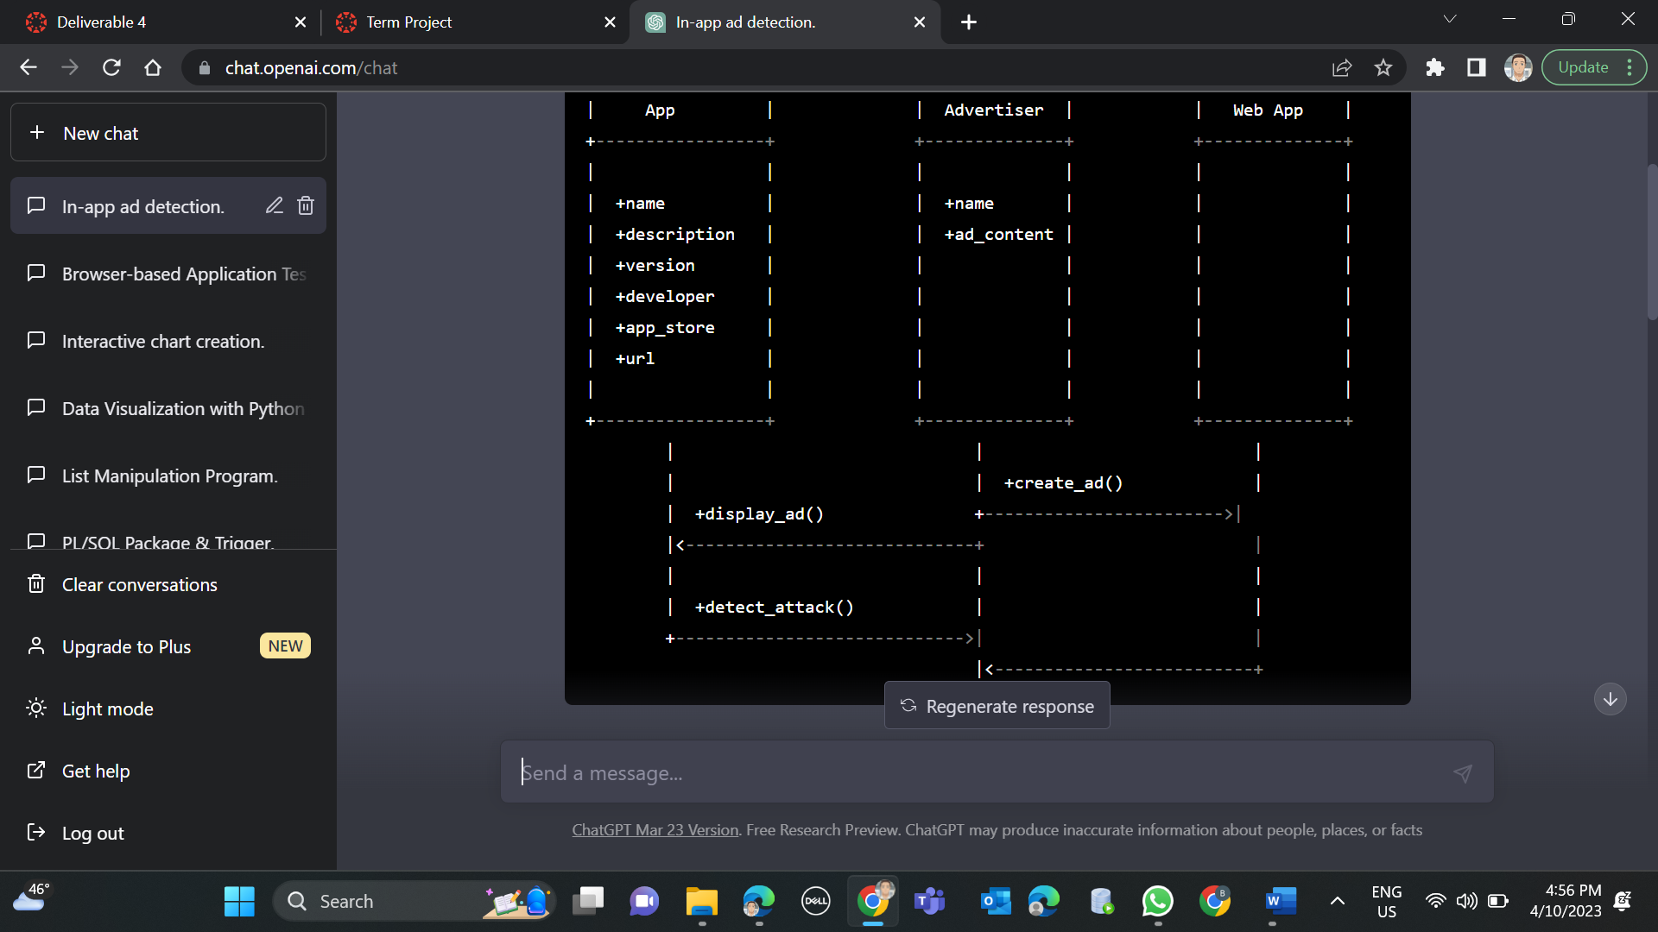

Another Class Diagram defining the application in simple functional format.

## Sequence diagram

Sequence diagram for “Understanding In-app Ads and Detecting Hidden Attacks through the mobile App -Web Interface.” with respect to the Phase – 1 Requirements.

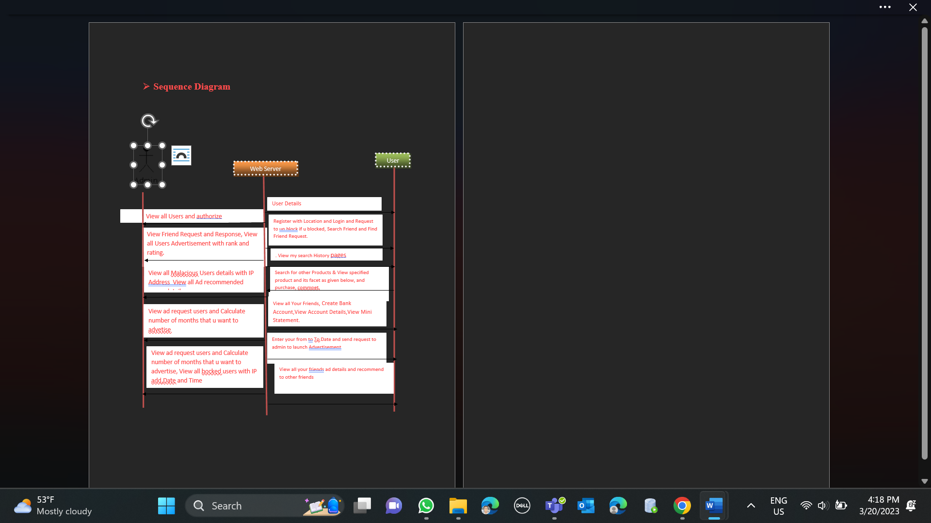

Figure : Sequence Diagram

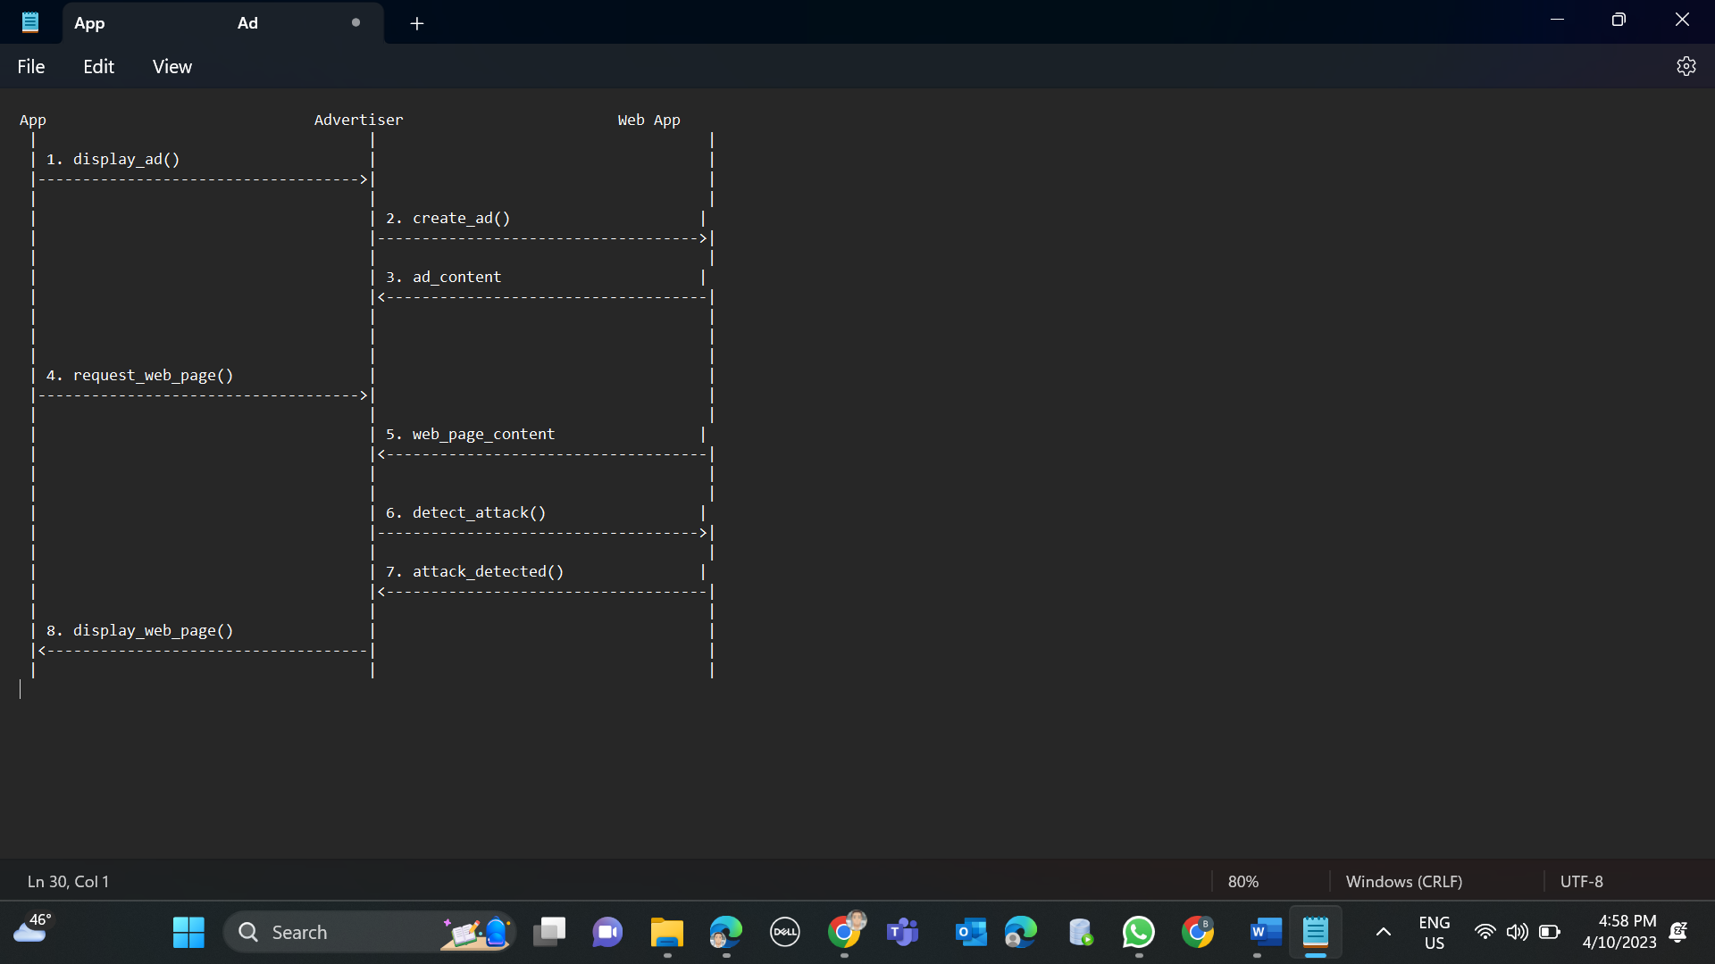

## Use case diagram

Use Case diagram for “**Understanding In-app Ads and Detecting Hidden Attacks through the mobile App -Web Interface.**” with respect to the Phase – 1 Requirements.

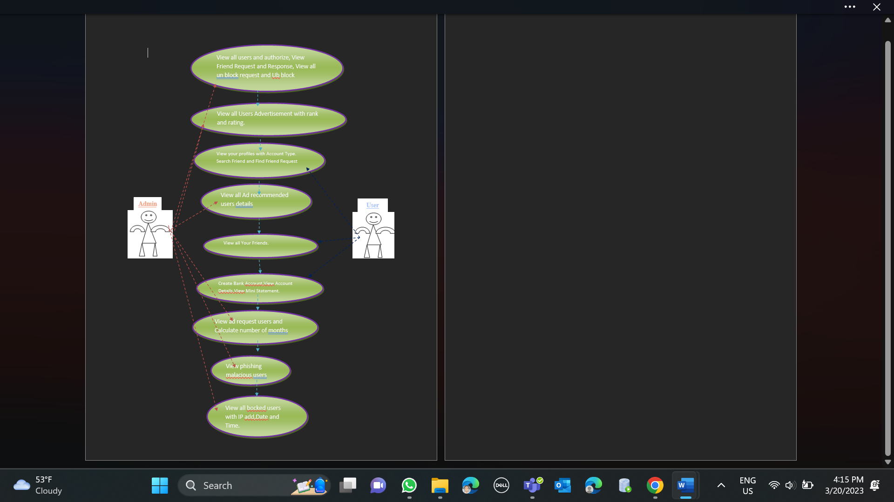

Figure : Use-case Diagram-normal case.

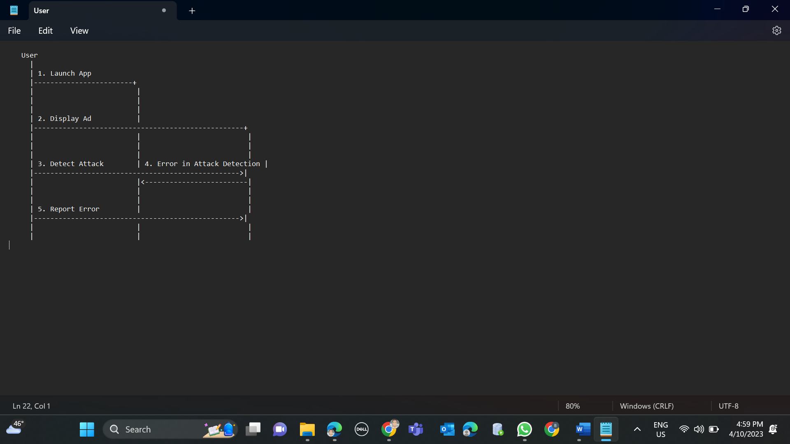

Test Cases

Test Cases:

1. To access the admin page here we need to provide the valid login credentials. If we fail to provide those credentials it will throw error. Based on this condition we tested the application, and the result was Pass.

In the below screen shot admin home page has shown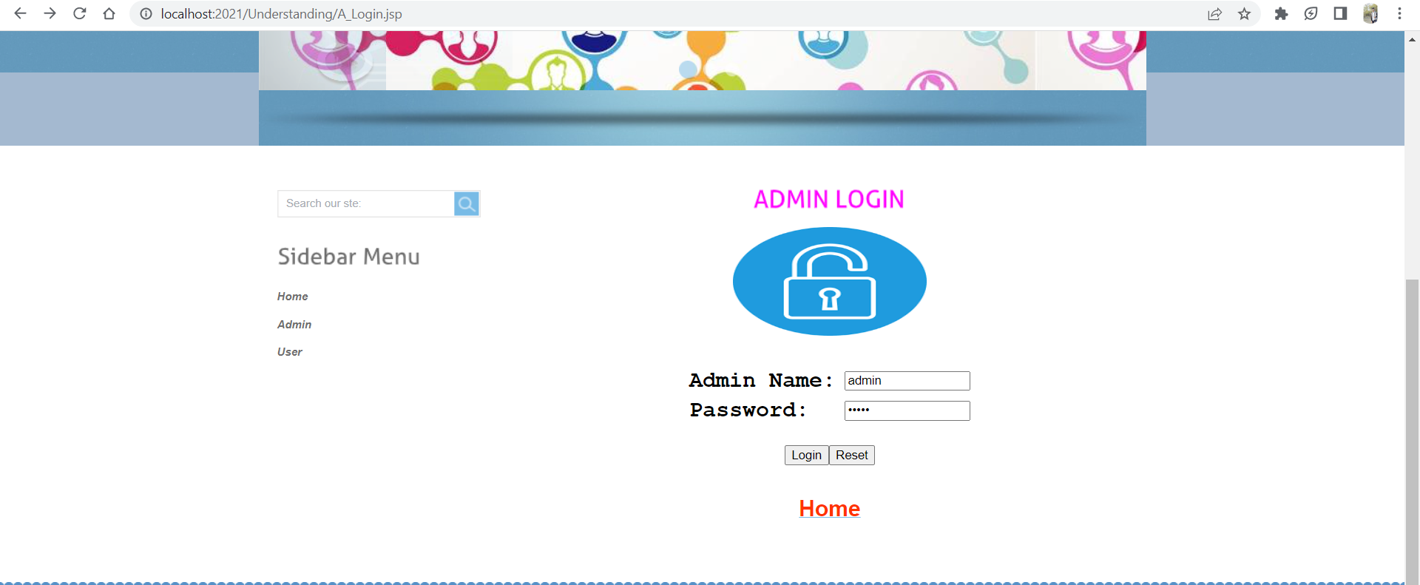

If we gave wrong login credentials, then it will redirect to this page

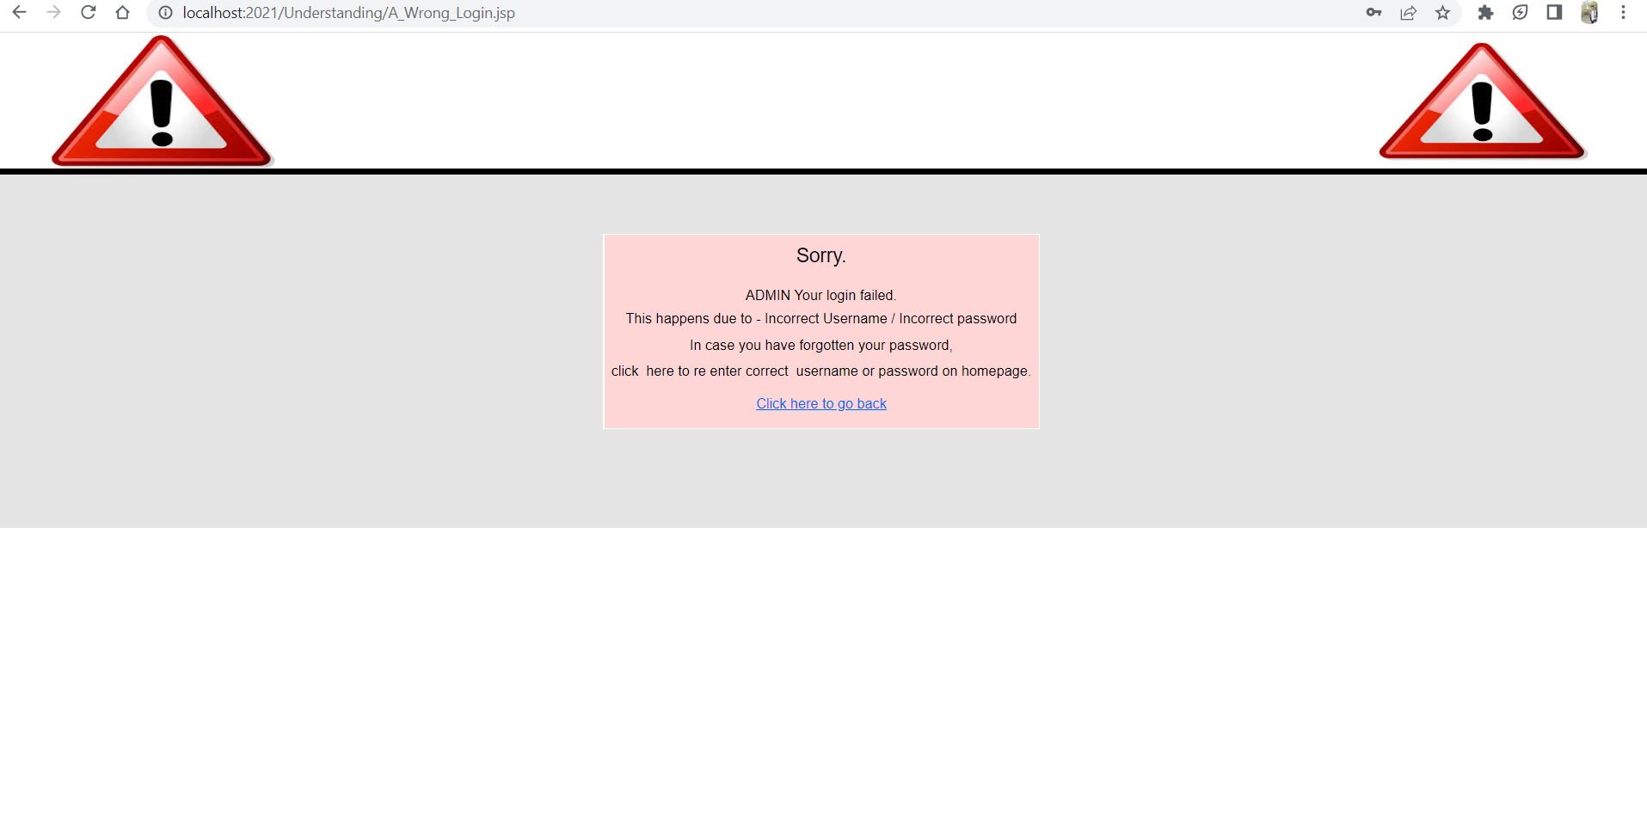

If we gave Correct credentials, it will display the admin welcome page

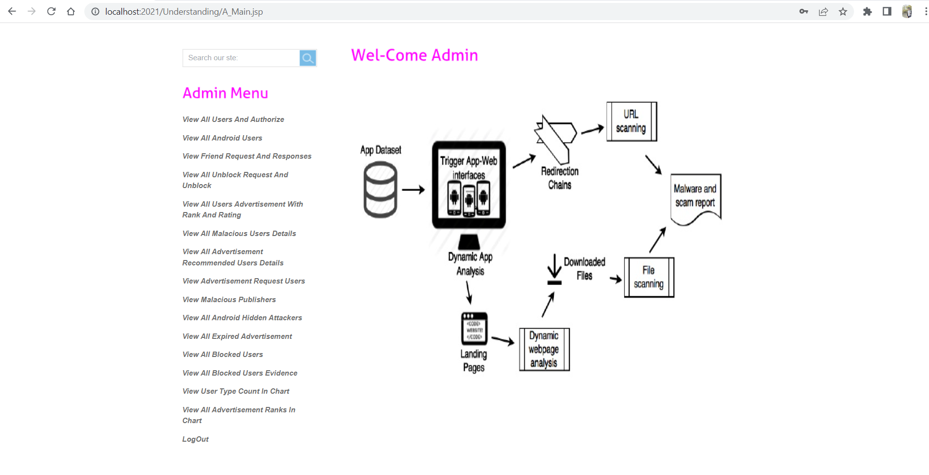

1. Similarly, we tested the user page also. This test case result was Pass.

In the below screenshot We entered wrong credentials.

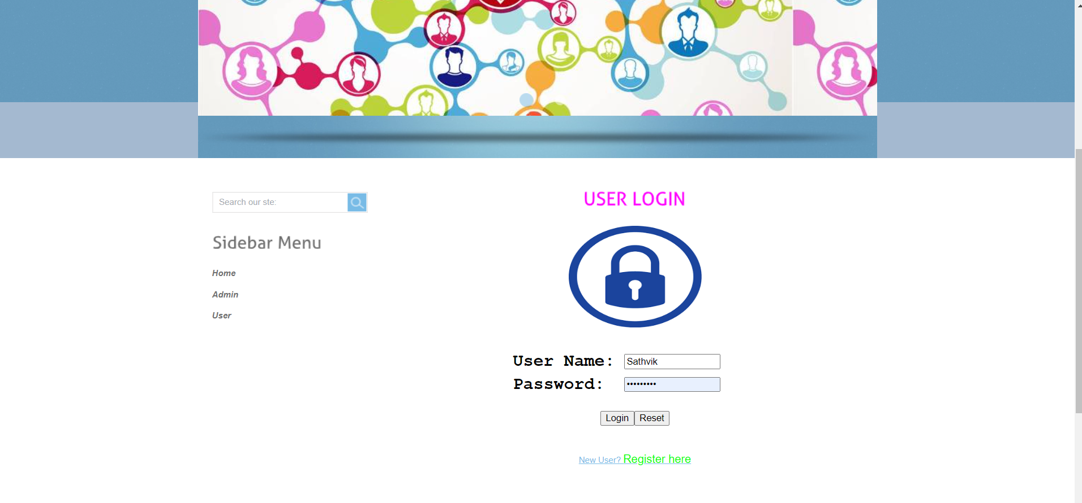

As we entered wrong credentials, the error as shown in the below screenshot

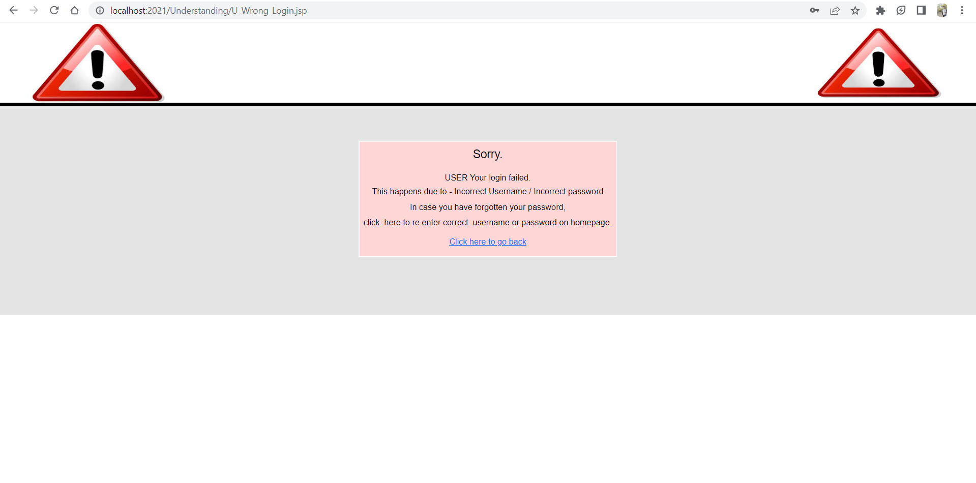

This time I gave correct credentials so, it is navigated to the user welcome page. 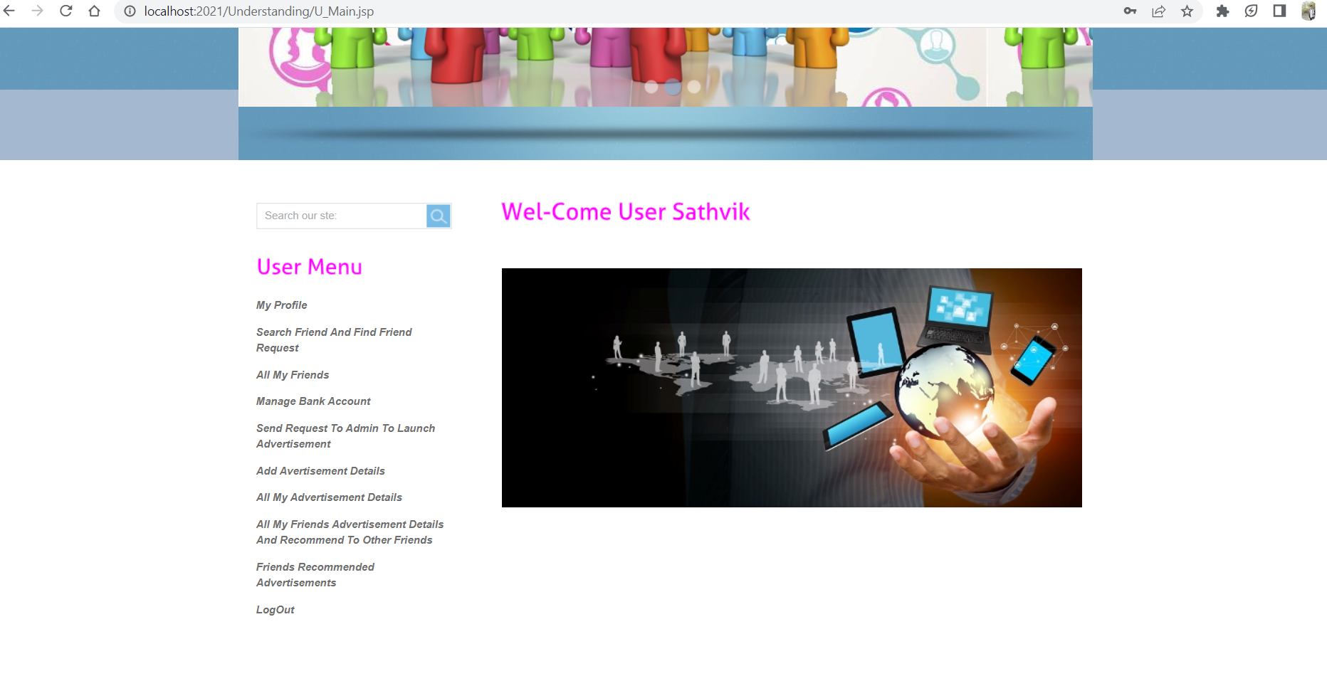

1. In this case we tried to login without giving any credentials, then the pop-up need to show for Please enter the credentials and this testcase result was Pass.

In the below screenshot we displayed popup window.

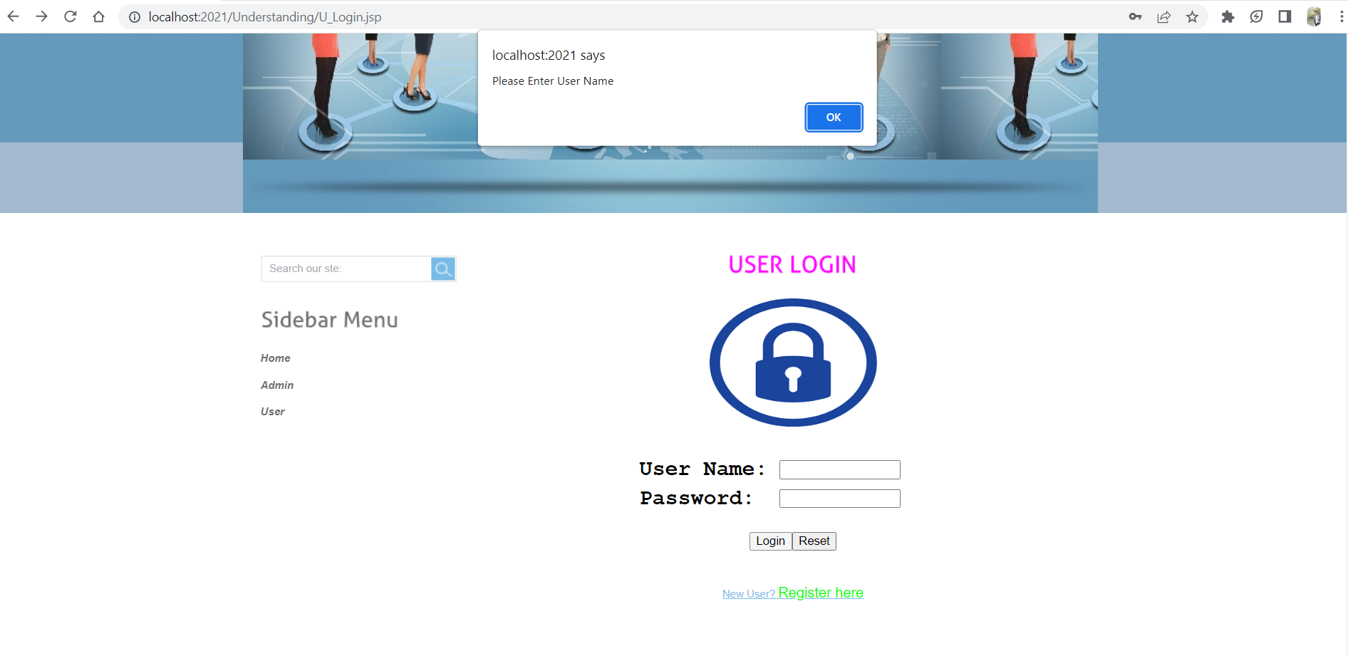

1. If the user is new to this application, he/she need to must register for accessing the webpage. For this case register page also working properly and this test case result was Pass.

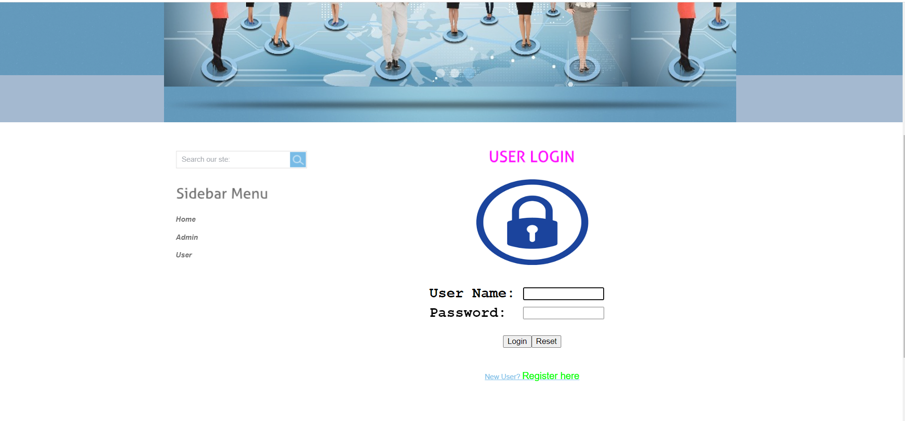

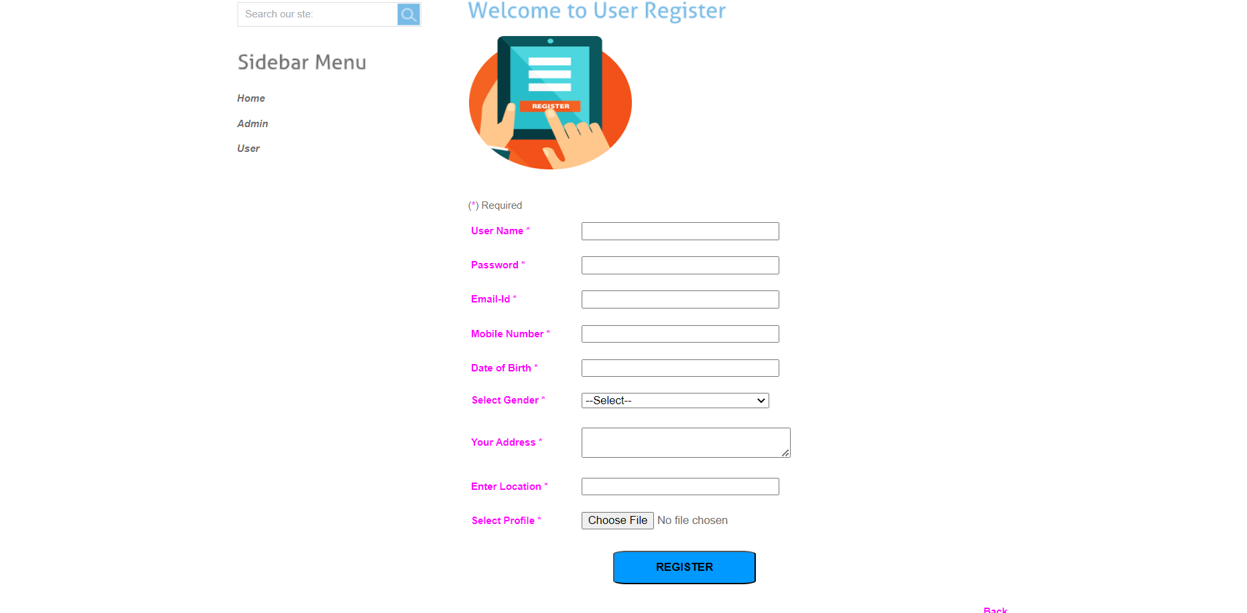

1. In this case we are trying to register without giving any details about the user. Popup windows need to show here for entering the details.

In the below screenshot that is what we shown and result of this testcase was Pass

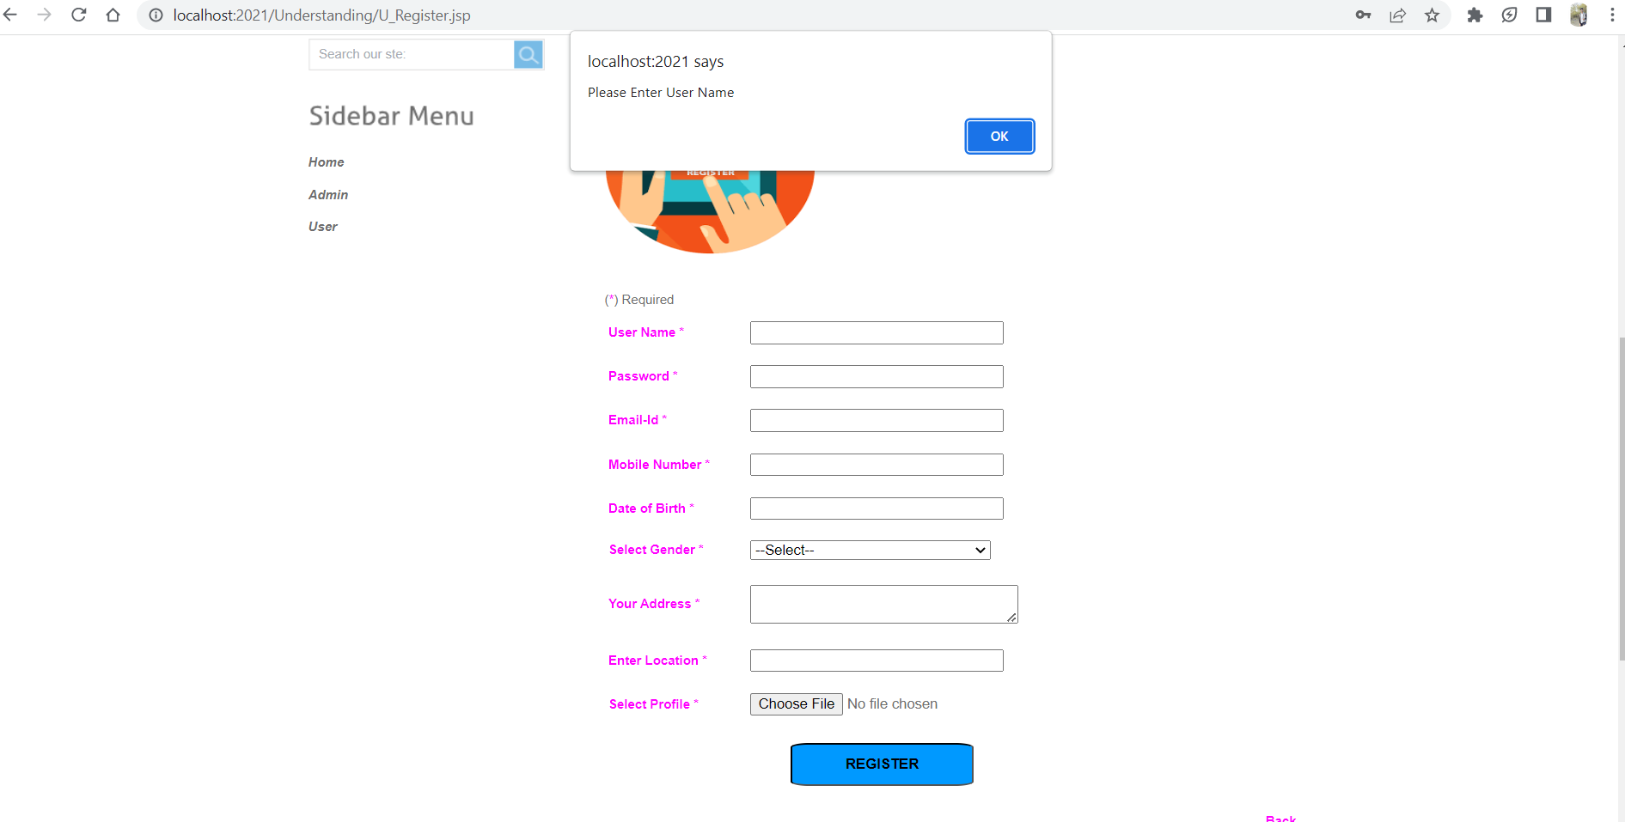

# Program Compilation and Run Instructions

1. **Program Instructions**

To compile and run the program and test cases on your local system, follow the instructions below. Make sure you have installed all required software and dependencies before continuing.

This requires the program to be compiled before it can be run or run.

***Compilation:*** The first step is to compile the program using an appropriate compiler or build tool. This is needed to generate the executable files that can be run on your system.

***Running the program:*** Once the compilation process is complete, you can run your program by running the generated executable file.

Here is a detailed explanation of the steps to compile and run the program on your local system using the Tomcat server.

***1. Download Tomcat:*** To run your program on your local system, you must first download and install the Tomcat server. You can download Tomcat from Apache Tomcat official website. Choose the version compatible with your operating system and download the ZIP or TAR file.  
  
***2. Extract the files:*** After downloading Tomcat, extract the contents of the ZIP or TAR file to a directory of your choice. This will create a new directory containing the tomcat files. You can extract the files using any extraction tool like WinRAR or 7-Zip.

***3. Start the server:*** To start the tomcat server, navigate to the bin directory of the tomcat directory you just extracted and run the startup application called Tomcat8.exe.

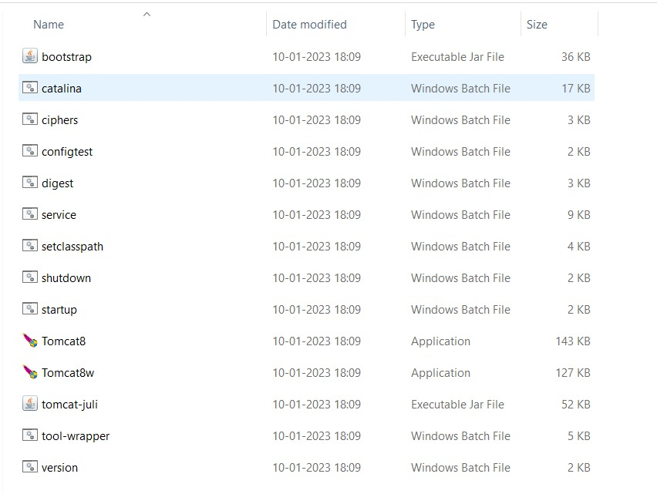

This will start the server as shown in the below screenshot and make it accessible at <http://localhost:2021/>.

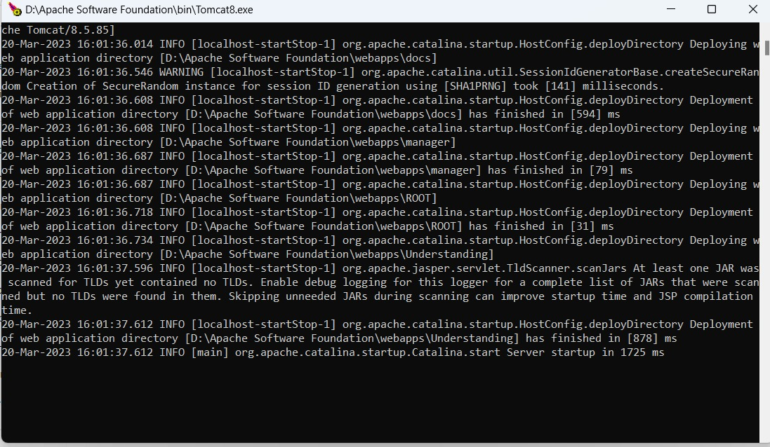

1. **Verify the installation:** For the verification of running the Tomcat server successfully, choose any web browser of your choice, open it and run the address as <http://localhost:2021/> . You can observe the Tomcat home page which is the default page of the application as in below screenshot. This confirms that Tomcat is running correctly on your system.

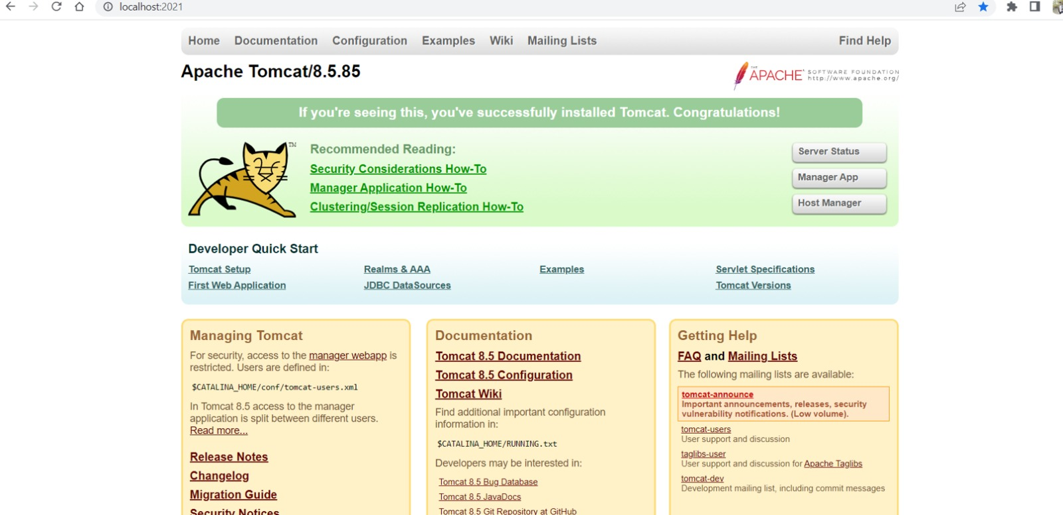

1. **Navigate to the application:** To navigate to the application’s home page, click on the Manager App button, which will take you to the Tomcat manager page where the list of all the available applications is showcased as in below screenshot.

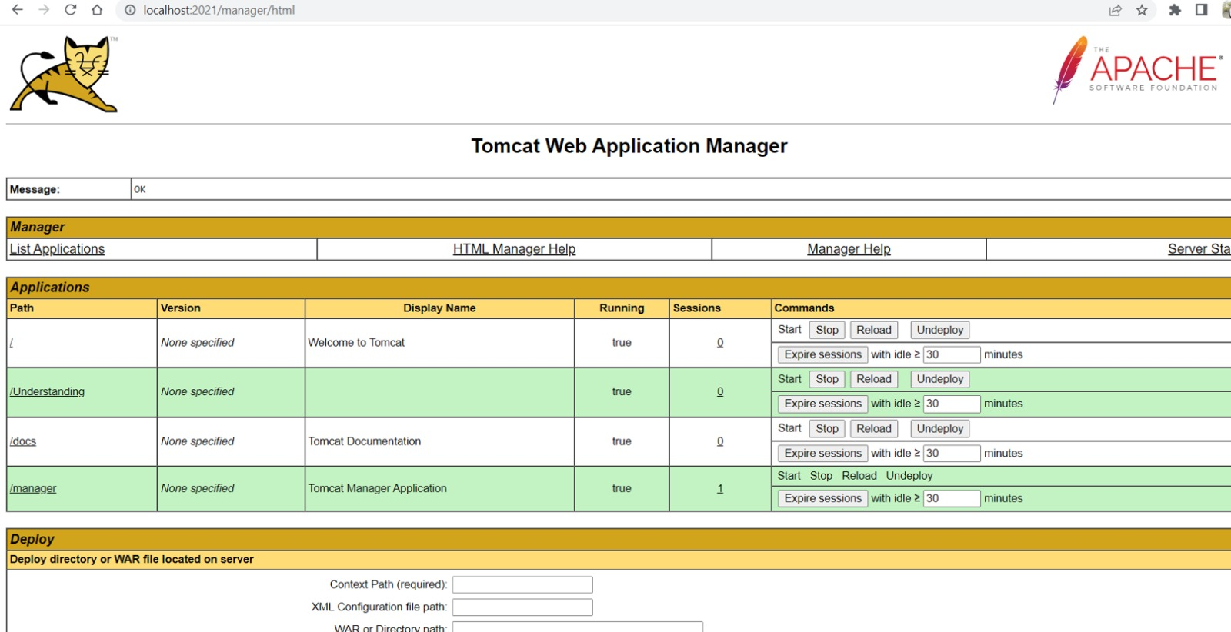

From there, click on the application that you want to run. As our application is ‘/Understanding’, click on that. If your application requires any credentials or login details, you will be prompted to enter them at this stage as shown in the screenshot below. For our application admin credentials are required.

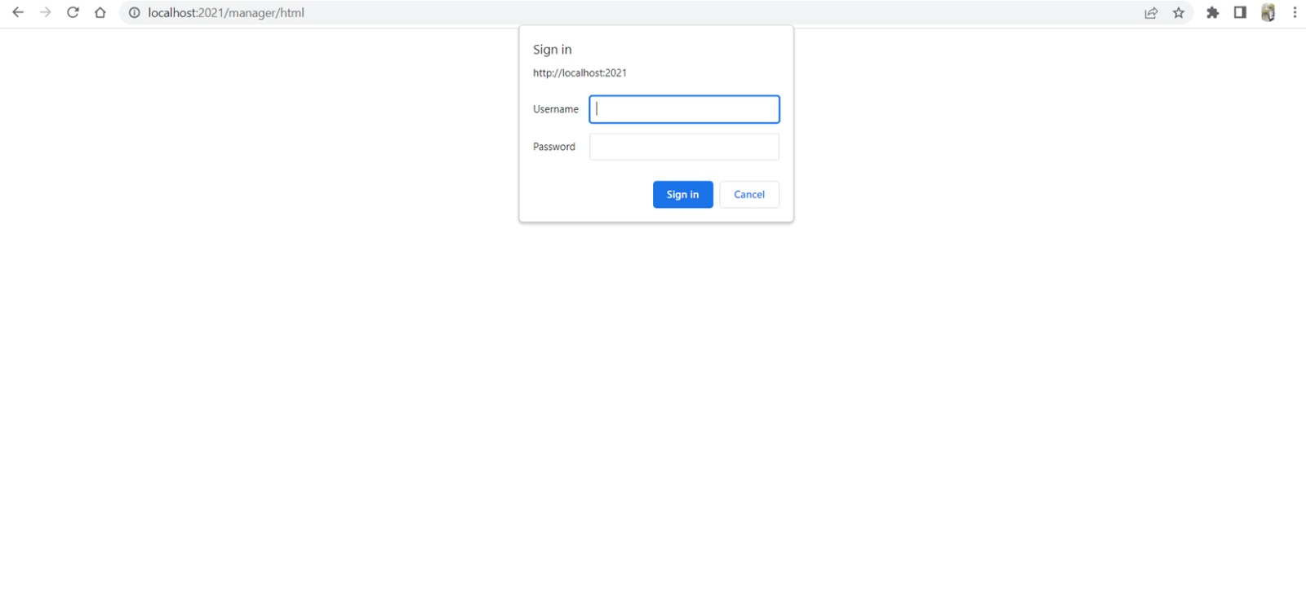

Congratulations, Here we have successfully installed and the tomcat server is successfully configured and the application in the local system.

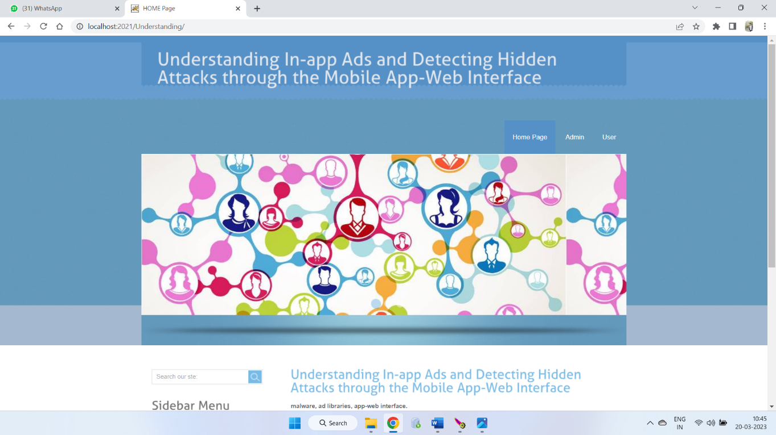

1. **Closing the server:** To stop the Tomcat server, navigate to the bin directory of the Tomcat directory and run the application named ‘Tomcat8w.exe’. This will open a command pallet where you can see that the server has been stopped.



1. **Testing Instructions**

This project is developed as a web application, which means it runs in a web browser. Therefore, to test the application, you must launch it in a web browser and run the program directly in the browser. The web application provides a user interface that allows you to interact with the program and test its functionality. By running the program itself in the browser, you can verify that the output generated by the application is correct and matches the expected output.  
  
To ensure that the application works properly and meets the required specifications, test the application by following the steps below:  
  
1. **Configure the application:** Make sure you have correctly configured the application on your local system by following the installation and configuration instructions provided.  
  
2. **Launch the application:** Launch the application by accessing the

URL http://localhost:2021/ in your web browser. This should take you to the app's home page.  
  
3. **Test each function:** Test each function of the app using the provided user interface. Make sure all buttons, links, and forms work as expected. Thoroughly test each feature of the application according to the test cases provided above to ensure that it meets the required specifications.  
  
4. **Verify output:** Verify that the output generated by the application is correct and matches the expected output. Make sure your application can detect and prevent attacks hidden in in-app ads.  
  
5. **Edge case testing:** Test the application with different inputs and edge cases to make sure it handles all possible scenarios correctly. Make sure your application can properly handle unexpected inputs and errors.  
  
6. **Retest**: Repeat the testing process multiple times to ensure consistency and reliability of the application.  
  
In summary, to compile and run the program and test cases on your local system, you need to compile the program, run the executable file, and use the web application UI opened in a web browser to run the test cases. By following these steps, you can ensure that your program works properly and meets the required specifications.

## Testing Instructions

As it is web application, most of the test cases executed as a part of Phase-1 were directly evaluated on the browser. Below are the steps:

The first step in testing is to prepare the application. In this case, the application is a web-based program that runs directly on the browser. Therefore, we will test each function of the program directly on the browser.

# Feedback

**Feedback Received:**

1. **Enhance User Experience:** Feedback received on making the UI more user-friendly so the displaying in-app ads will not distract users.
2. **Ad Block Feature:** Got suggestion to implement a feature that blocks the in-app ads which are not needed for users.
3. **Account Privacy:** Received advice to secure the privacy of user’s bank details and personal information.

**Suggestions Accepted:**

***Enhance User Experience*:** As suggested we have enhanced the features of the web-interface so that the in-app ads were not a distraction for users. Adjusted the UI to be responsive and user-friendly by changing the CSS and also the front-end code. Made changes such as changing the alignment and positioning to make the web interface more appealing to the end-users. Tested the application after the feature implementation on different devices with different resolutions.

***Account Privacy:*** Updated the web application for the protection of the information collected from users and safe preserving. Also implemented stricter policies of data privacy to ensure secure storage and information retrieval. Also encrypted the data end to end that other users even the administration cannot access other’s account information. Data stored was encrypted using different encoding techniques for the safe privacy of the user’s personal data.

**Suggestions Rejected:**

***Ad Block Feature:*** Even though the suggested feature to block the in-app ads that are irrelevant to the users. For reasons of time constraints and code complexity we have not implemented this feature. It is a good and useful feature that can be developed if there are time and feasible requirements for the web application updates.

# Accomplishments

A Complete reflection of work for this phase:

1. In this Increment we worked on all the three modules of the project and the database.

2. In the Admin Module we worked on the changes should be made to the other modules according to the request raised by the other users like functionalities triggering to permit the request of posting adds and blocking users according to the ads posted.

3.In the Mobile User module there should be the functionalities affecting the database according to the requests made by the admin side.

4.Updating the database according to the modules requirement with some extra records and also some new attributes(Columns) for effective working of application.

# Member contribution table

|  |  |  |  |
| --- | --- | --- | --- |
| **Member Name** | **Contribution Description** | **Overall Contribution (%)** | **Note (If Applicable)** |
| **Sushma Bobbishetty** | Functional and Non-Functional requirement specification and Full Stack Development, worked on all components. | 15 |  |
| **Sathvik Cheekati** | Program Compilation and Run Instructions. Front-end development of customer, employee, and manager modules. | 16 |  |
| **Navyasri Arekatla** | Test Cases and Back-end development of customer, employee, and manager modules. | 12 |  |
| **Naveen Bolgom** | Feedback and accomplishments. Back-end development of customer, employee, and manager modules. | 12 |  |
| **Lokesh Bachu** | Code-inspection document. Front-end development of customer, employee, and manager modules. | 15 |  |
| **Vamshi Teja Goud Puli** | User Manual and Application Layer Development. UML Designs and Initial Integrated Testing. | 13 |  |
| **Shiva Teja Reddy Yammanuru** | Code-inspection document and GitHub update and Application and UI Development. | 15 |  |

# VIII Reflection

In this phase of the project, we achieved the following:

1.At the application layer, Java servlet pages are still being built to improve the capabilities and speed of web interfaces.

2. All front-end web pages for modules have been changed to add new features and make the user experience better. Servlet pages, jQuery, and Ajax are still used to build the system.

3. Updates to the database that are needed to keep the project moving smoothly in all ways.

4. Ongoing back-end work for updated admin, user, and Android modules to make sure that all functionality is properly included in the database and system architecture.

5. Used the functions from the peer team's plan, which they got at the code inspection workshop.

6. Do detailed tests to make sure the system is error-free and working well. We gave the application the Apache Tomcat server and did a lot of testing to make sure that everything works as it should.

Overall, the team has hit important milestones in the project's development, such as making a working database, making applications and front layers, and putting together different parts. We were able to update more features and implement suggestions from the partner team, which made the application more secure and improved the user interface and general user experience. Our team has always worked well together, and we have training classes regularly to make sure that everyone is on the same page. But we could have done a better job of communicating and working together as a team. We also could have done a better job of testing by doing more and more testing before putting the app out there.